**Major Assignment - 2**

**On**

**Python for Computer Science and**

**Data Science 1 (CSE 3651)**

**Submitted by**

**Name : Dinanath Dash**

**Reg. No. : 2241004161**

**Semester : 5th**

**Branch : CSE**

**Section : 2241026**

**Session : 2024-2025**

**Admission Batch : 2022**



**DEPARTMENT OF COMPUTER SCIENCE & ENGINEERING**

**FACULTY OF ENGINEERING & TECHNOLOGY (ITER)**

**SIKSHA ‘O’ ANUSANDHAN DEEMED TO BE UNIVERSITY**

BHUBANESWAR, ODISHA – 751030

Python for Computer Science and Data Science 1 (CSE 3651)

**Major Assignment-2: Mutable and Immutable Objects**

**Operation Navjeevan**

You are an advanced intelligence agent working for a humanitarian organization **Indian Taskforce for Emergency Relief**. As part of the organization, you are closely monitoring the **Russia-Ukraine War**. Your mission, should you choose to accept, is to analyze data to assist in providing aid and resources to those affected by the devastating war.

Note: Examples are provided with all questions for illustration purposes only. When you are solving the actual problems, you have to take different examples (some of the items in the examples can be common with your examples).

Good luck soldier! Heroes are not born in the mother’s womb, they are born on the battlefield.

# Mission1) Clearing the Field

Both Russia and Ukraine have critical resources contributing to their respective war efforts. However, Russia has significant backup and Ukraine requires immediate aid. You have received a list containing the names of cities in Ukraine where your organization is planning to send aid. Some cities are listed multiple times due to multiple aid requests.

# Task:

* Write a Python function that removes duplicates from the list and sorts it alphabetically.
* Return the cleaned list.

# Example:

**Input:**

cities = [“Kyiv”, “Kharkiv”, “Odessa”, “Kyiv”, “Lviv”, “Kharkiv”, “Dnipro”]

# Output:

cleaned cities=[“Dnipro”, “Kharkiv”, “Kyiv”, “Lviv”, “Odessa”]

Screenshot: -

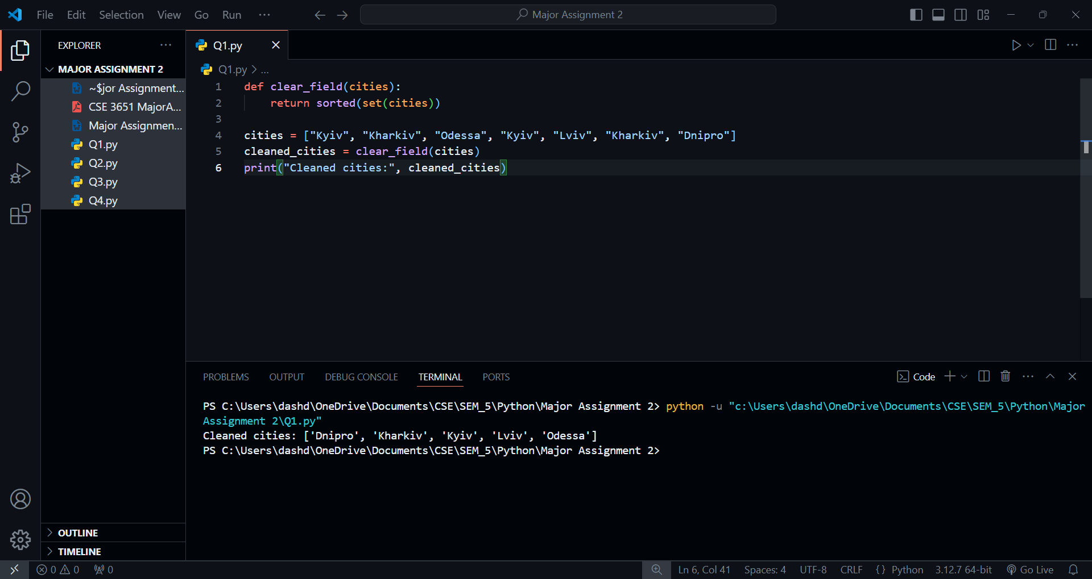



# Mission2) High Alert Identification

As per previous intel, assume you already have a set of cities which require aid most frequently. You can use the concept of set to perform the current tasks, which constitute the following:

* Find out all cities requiring aid considering the cleaned list of cities from Mission1 as well as the ones obtained from the previous intel.
* Find cities that are unique to both the cleaned list of cities from Mission1 and the ones obtained from the previous intel.
* Using the cleaned list of cities from Mission1, identify which cities are common between that list and the cities obtained from the previous intel. They are the ones on high alert.

# Example:

**Input:**

cleaned cities = *{*“Dnipro”, “Kharkiv”, “Kyiv”, “Lviv”, “Odessa”*}* previous intel = *{*“Kyiv”, “Mariupol”, “Lviv”, “Donetsk”*}* **Output:**

*{*“Dnipro”, “Kharkiv”, “Kyiv”, “Lviv”, “Odessa”, “Mariupol”, “Donetsk”*}*

*{*“Mariupol”, “Odessa”, “Donetsk”, “Dnipro”, “Kharkiv”*}*

*{*“Kyiv”, “Lviv”*}*

Screenshot: -

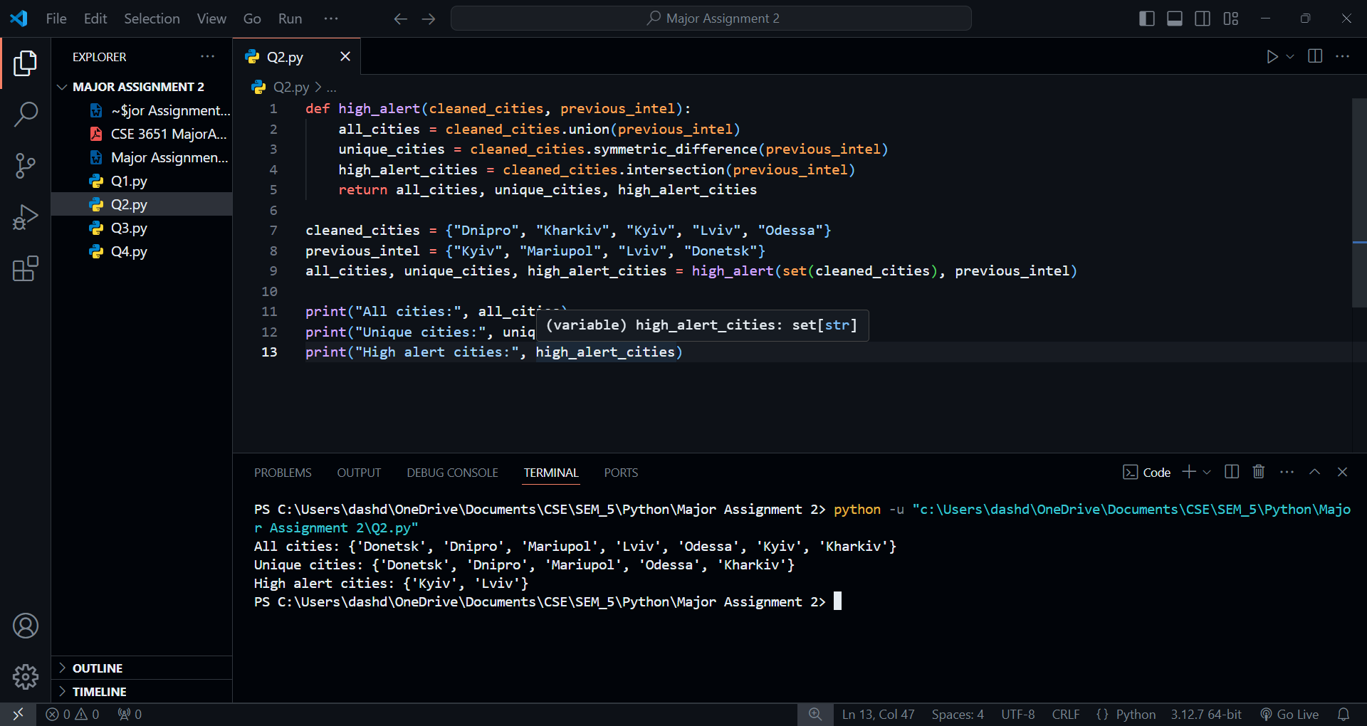



# Mission3) Detailed City Intel

With detailed reconnaissance, you now have more exhaustive information about some cities, stored in tuples in a list. Each tuple contains the city name, population, and the number of aid requests received.

# Task:

* Take the set of high alert cities from Mission2 and a list of tuples containing relevant data.
* Return a dictionary where the keys are the city names and the values are the corresponding tuples.
* Also find the population and the number of aid requests received overall from the cities obtained in the dictionary.

# Example:

**Input:**

high alert cities = “Kyiv”, “Lviv” city data = [(“Kyiv”, 2800000, 250), (“Kharkiv”, 1431000, 180), (“Lviv”, 721301, 90), (“Odessa”, 1029049, 120)]

# Output:

high alert cities info = *{*“Kyiv”: (“Kyiv”, 2800000, 250), “Lviv”: (“Lviv”, 721301, 90)*}*

3521301

340

Screenshots: -

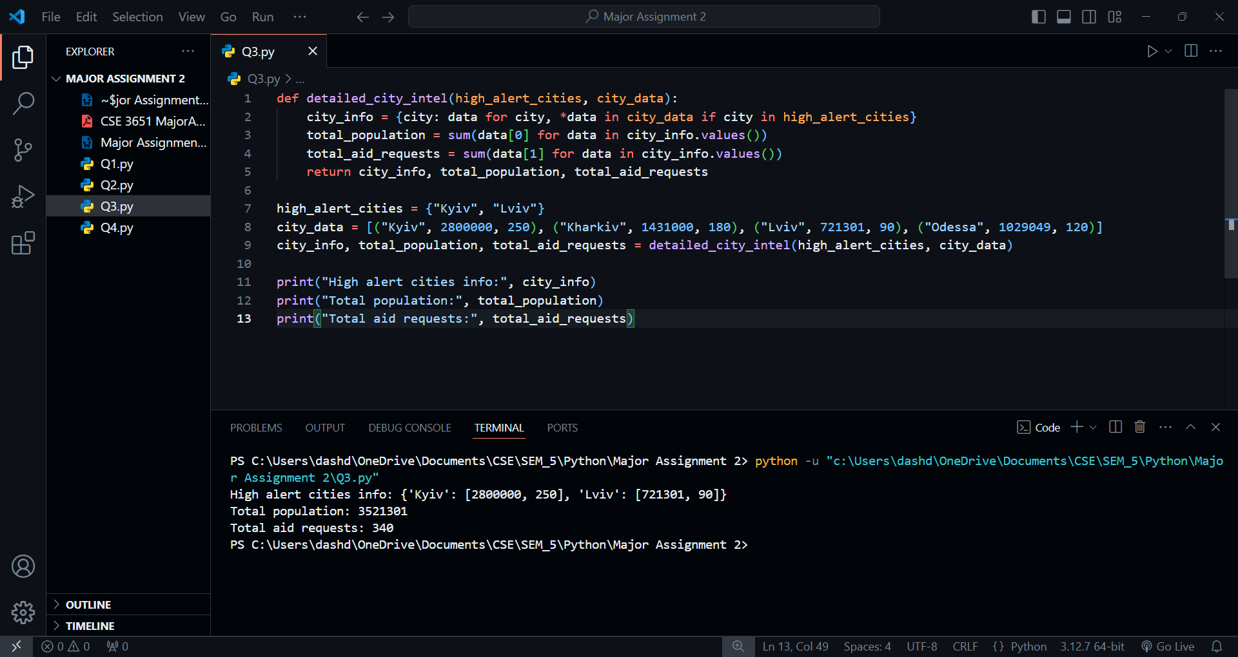



# Mission4) Tracking Supply Distribution

You need to create a data structure to track the types and quantities of supplies sent to cities in both Ukraine and Russia.

# Task:

* Take a list of tuples. Each tuple contains the city name (from both Ukraine and Russia), type of supply, and quantity sent.
* Return a nested dictionary where the keys are city names and the values are dictionaries with supply types and quantities.

# Example:

**Input:**

supplies = [(“Kyiv”, “Food”, 500), (“Moscow”, “Medicines”, 200), (“Lviv”, “Water”, 300), (“Saint Peters- burg”, “Blankets”, 100), (“Kharkiv”, “Food”, 150)]

# Output:

*{*“Kyiv”: *{*“Food”: 500*}*, “Moscow”: *{*“Medicines”: 200*}*, “Lviv”: *{*“Water”: 300*}*, “Saint Petersburg”:

*{*“Blankets”: 100*}*, “Kharkiv”: *{*“Food”: 150*}}*

Screenshots: -

